**SY 23-24 Developmental Screenings**

* September 25, 2023
* October 30, 2023
* November 27, 2023
* December 18, 2023
* January 29, 2024
* February 26, 2024
* March 25, 2024
* April 29, 2024
* May 20, 2024
* June 24, 2024

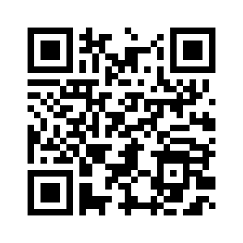

Screenings are scheduled by appointment only. Please use the following link or scan the QR code to request a Developmental Screening. <https://forms.gle/cE1SWa9u5LPeVKr58>

Screenings occur at the following location

Cardinal O’Connell Early Learning Center

21 Carter St.

Lowell MA, 01852

All persons attending the screening must sign in at the front office upon entering the building and show proper photo identification.

If you have any questions, please contact Susan LaCroix at 978-674-2050 or [slacroix@lowell.k12.ma.us](mailto:slacroix@lowell.k12.ma.us)